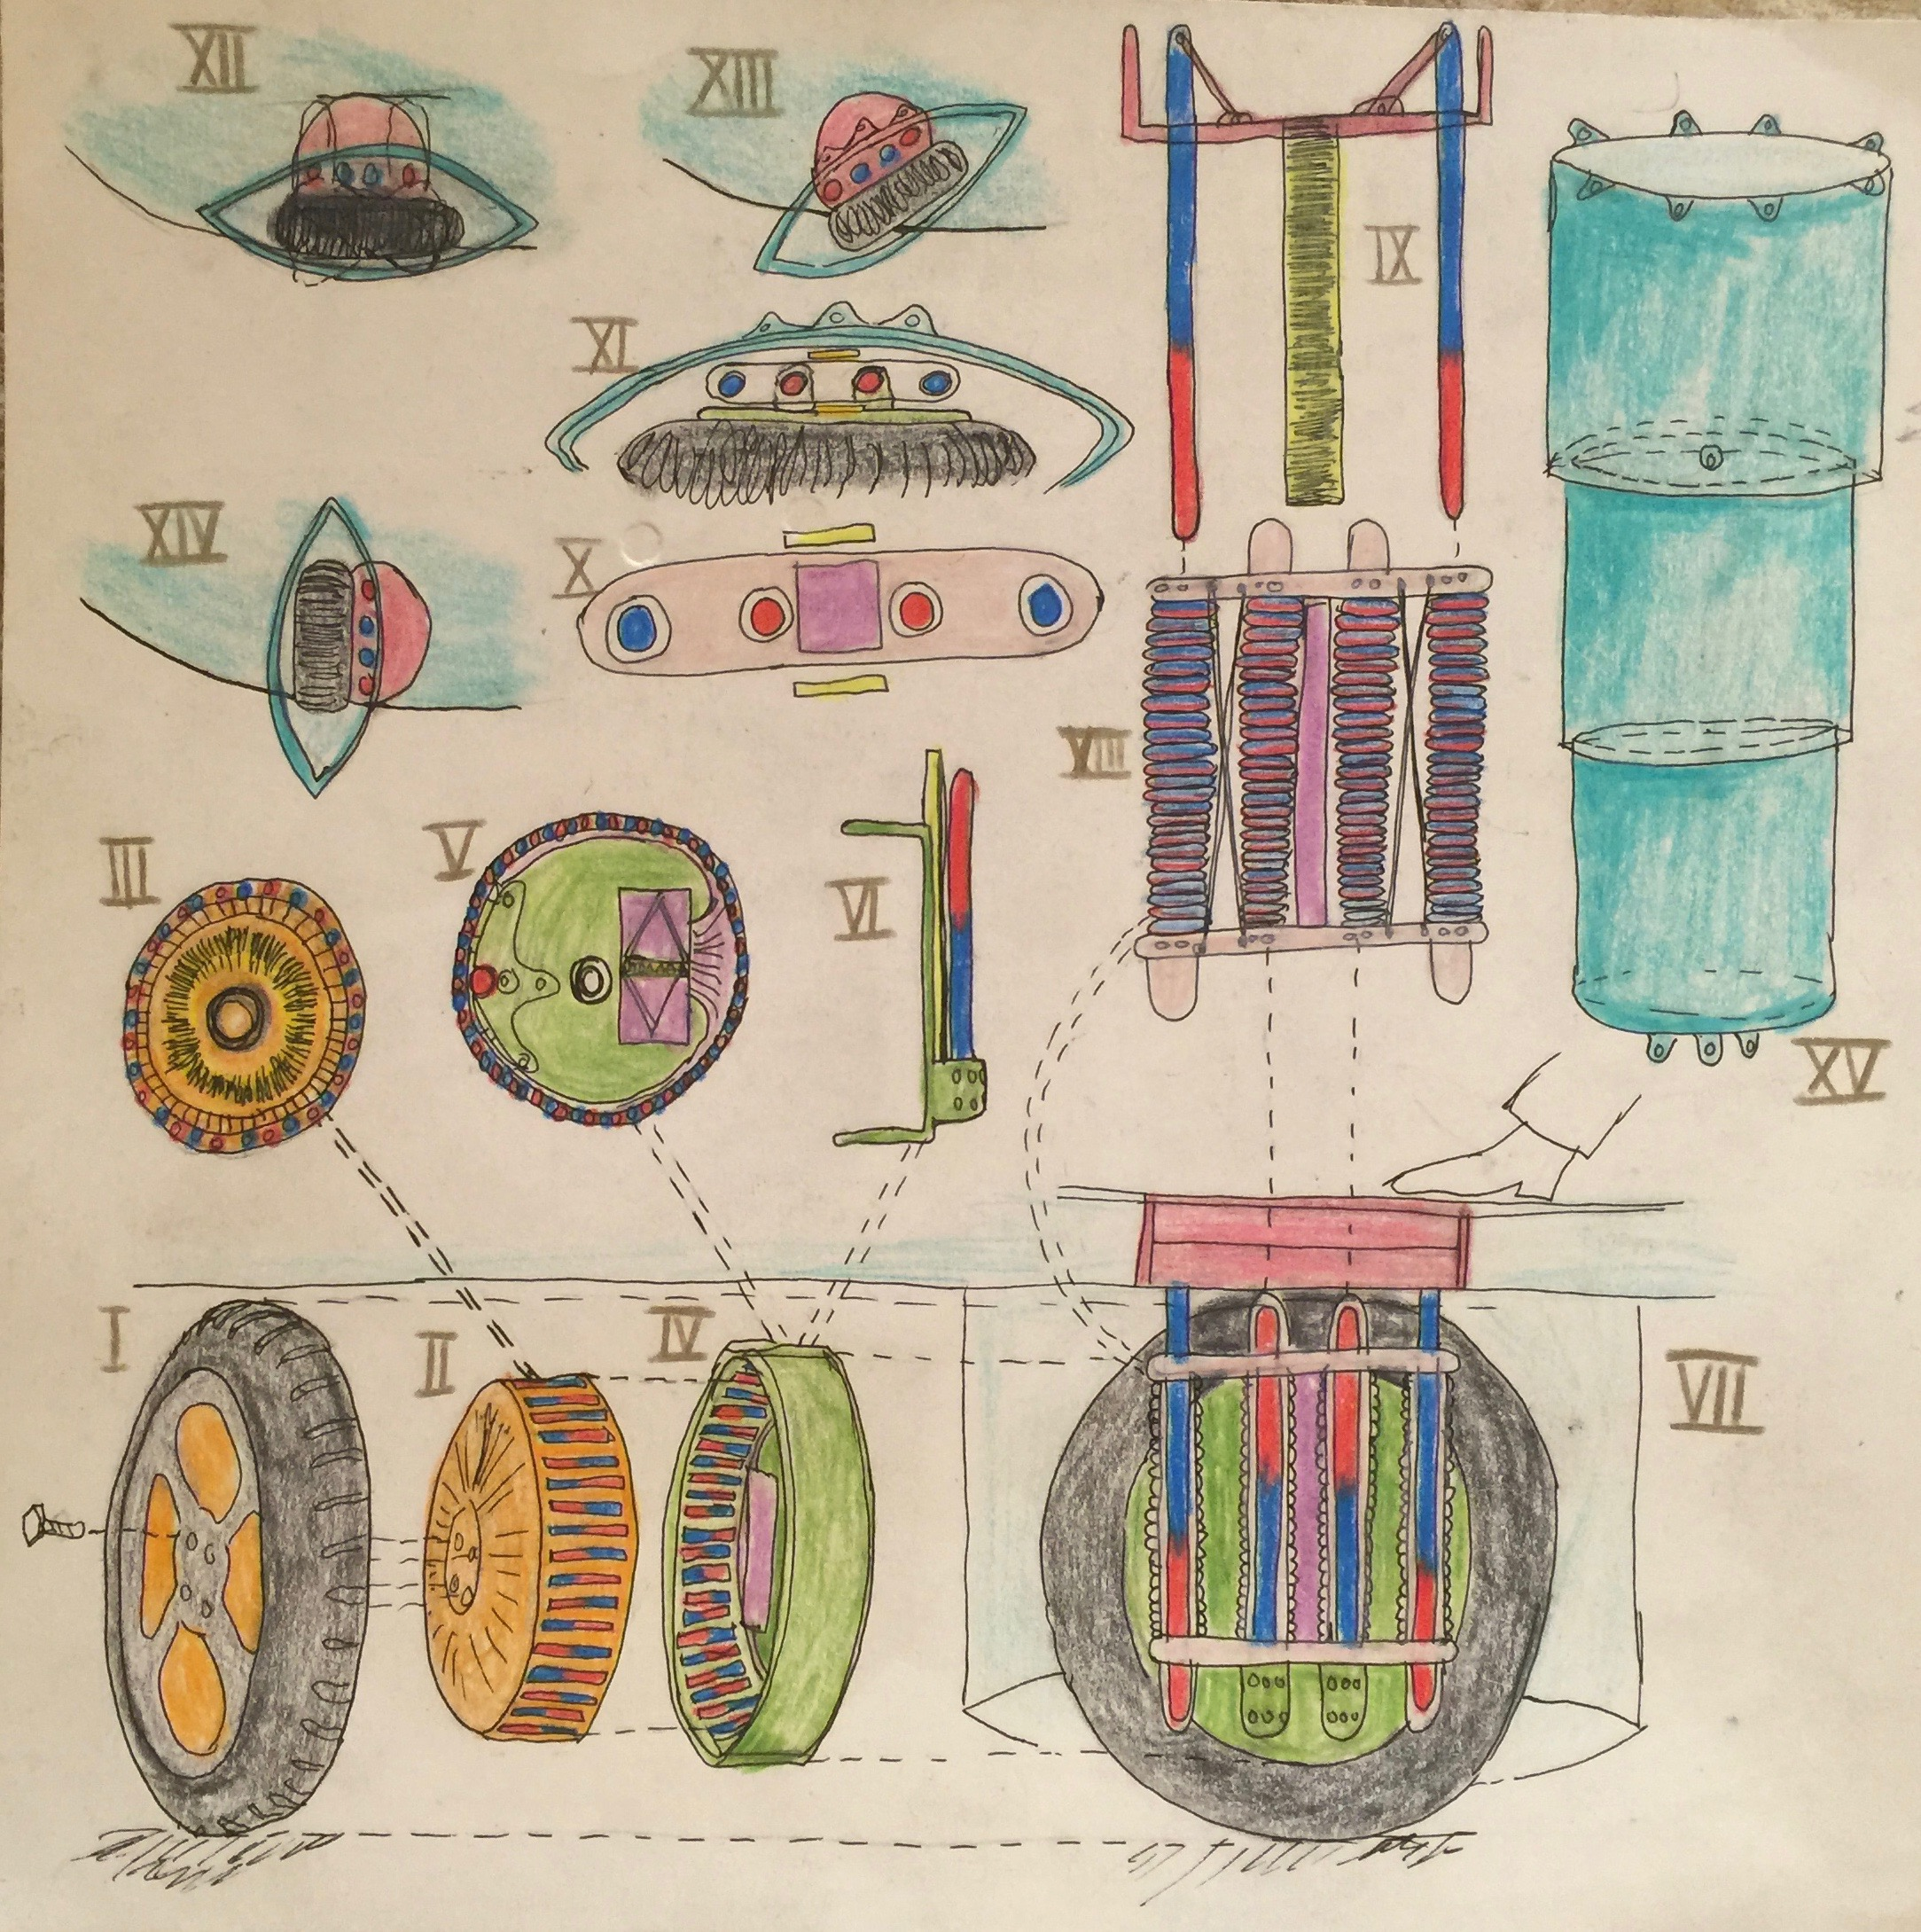Klima Ko-op – Traction Wheel

Week ending Sun 31 Jan 2016

Wheel Progress Report

# Achieved Mon 25 Jan – Sun 31 Jan 2016

*Advanced detailed design for printing plastic of wheel and cutting metal of wheel. I think I have all of the components in hand now too.*

# Design and Fabrication of Cutting Jig

*The aim here is to cut the metal bars and rods I have into the main parts of the magnetic circuit. Cuts are needed at 121, 100, 14 and 12mm.*

1. I’ve designed in OpenSCAD the exact geometry (that feeds the 3D printer) to make a cutting jig. The aim is to cut six pieces of metal at 12mm x 2, 14mm x 2, 100mm and 121mm. The raw mild steel is 12x12, 10x3 and 6mm diameter.
2. Printing the main part of the jig proved to be fun and games [see picture below] as a) the system said it wanted 8 hours to print it and b) it printed lots of filament bed support in a strange pad that I’d not predicted and c) many print runs failed. (bolded are the minimumsolutions below).
3. Dave B and I have discussed options for sawing this metal at quite some length. There are several options to explore
   1. Angle grinder (which I have one of ) would keep cutting without going blunt. I bought two new thin blades for it. I studied YouTube videos for getting the retaining nut off that holds the blade on. It is ‘lefty loosey, righty tighty’.
   2. I’ve looked into renting a suitable metal chop saw.
   3. Even though I could get a metal shop to do the cuts, the ones I’ve had done to date are not very accurate. They claim + or – 2mm which is shocking to me! I think I can do much better.
   4. There may be a simpler way to mock up the jig for the jigsaw using G clamps and bits of wood.
   5. David has offered to saw and screw together a jig for the jig saw, but fears it’ll go blunt too quickly. [such a jig not needed (at least for now)].
4. My next steps
   1. Study my wood-saw table and see if it can be adapted – with the angle grinder firmly duct taped onto one leg – and a moving platform with end stop to move the stock along and into the path of the angle grinder. Care with fingers!
   2. Fallback option: I’ve identified a rental chop saw that will do the job from TP.
5. *Lesson learned 1: Where complexly shaped parts have to fit together it is essential to model them together, so that clever ideas to simplify one part do not mess up its fit with another part. Lesson learned 2: It is necessary to zoom right in to check all parts of the model, even to 0.01mm to ensure that my calculations are correct. LL 3: Calculate everything, so that if you change one dimension then all of its repercussions are automatically recomputed. LL4: take into account air gaps around parts so that they can be neatly inserted into their holes. LL5: Ensure parts subject to magnetic forces are held snuggly into their holes without rattling (the covers shown below achieve this – they slide into place). What I haven’t yet taken into account is variability in cutting tolerance of the metal parts.*

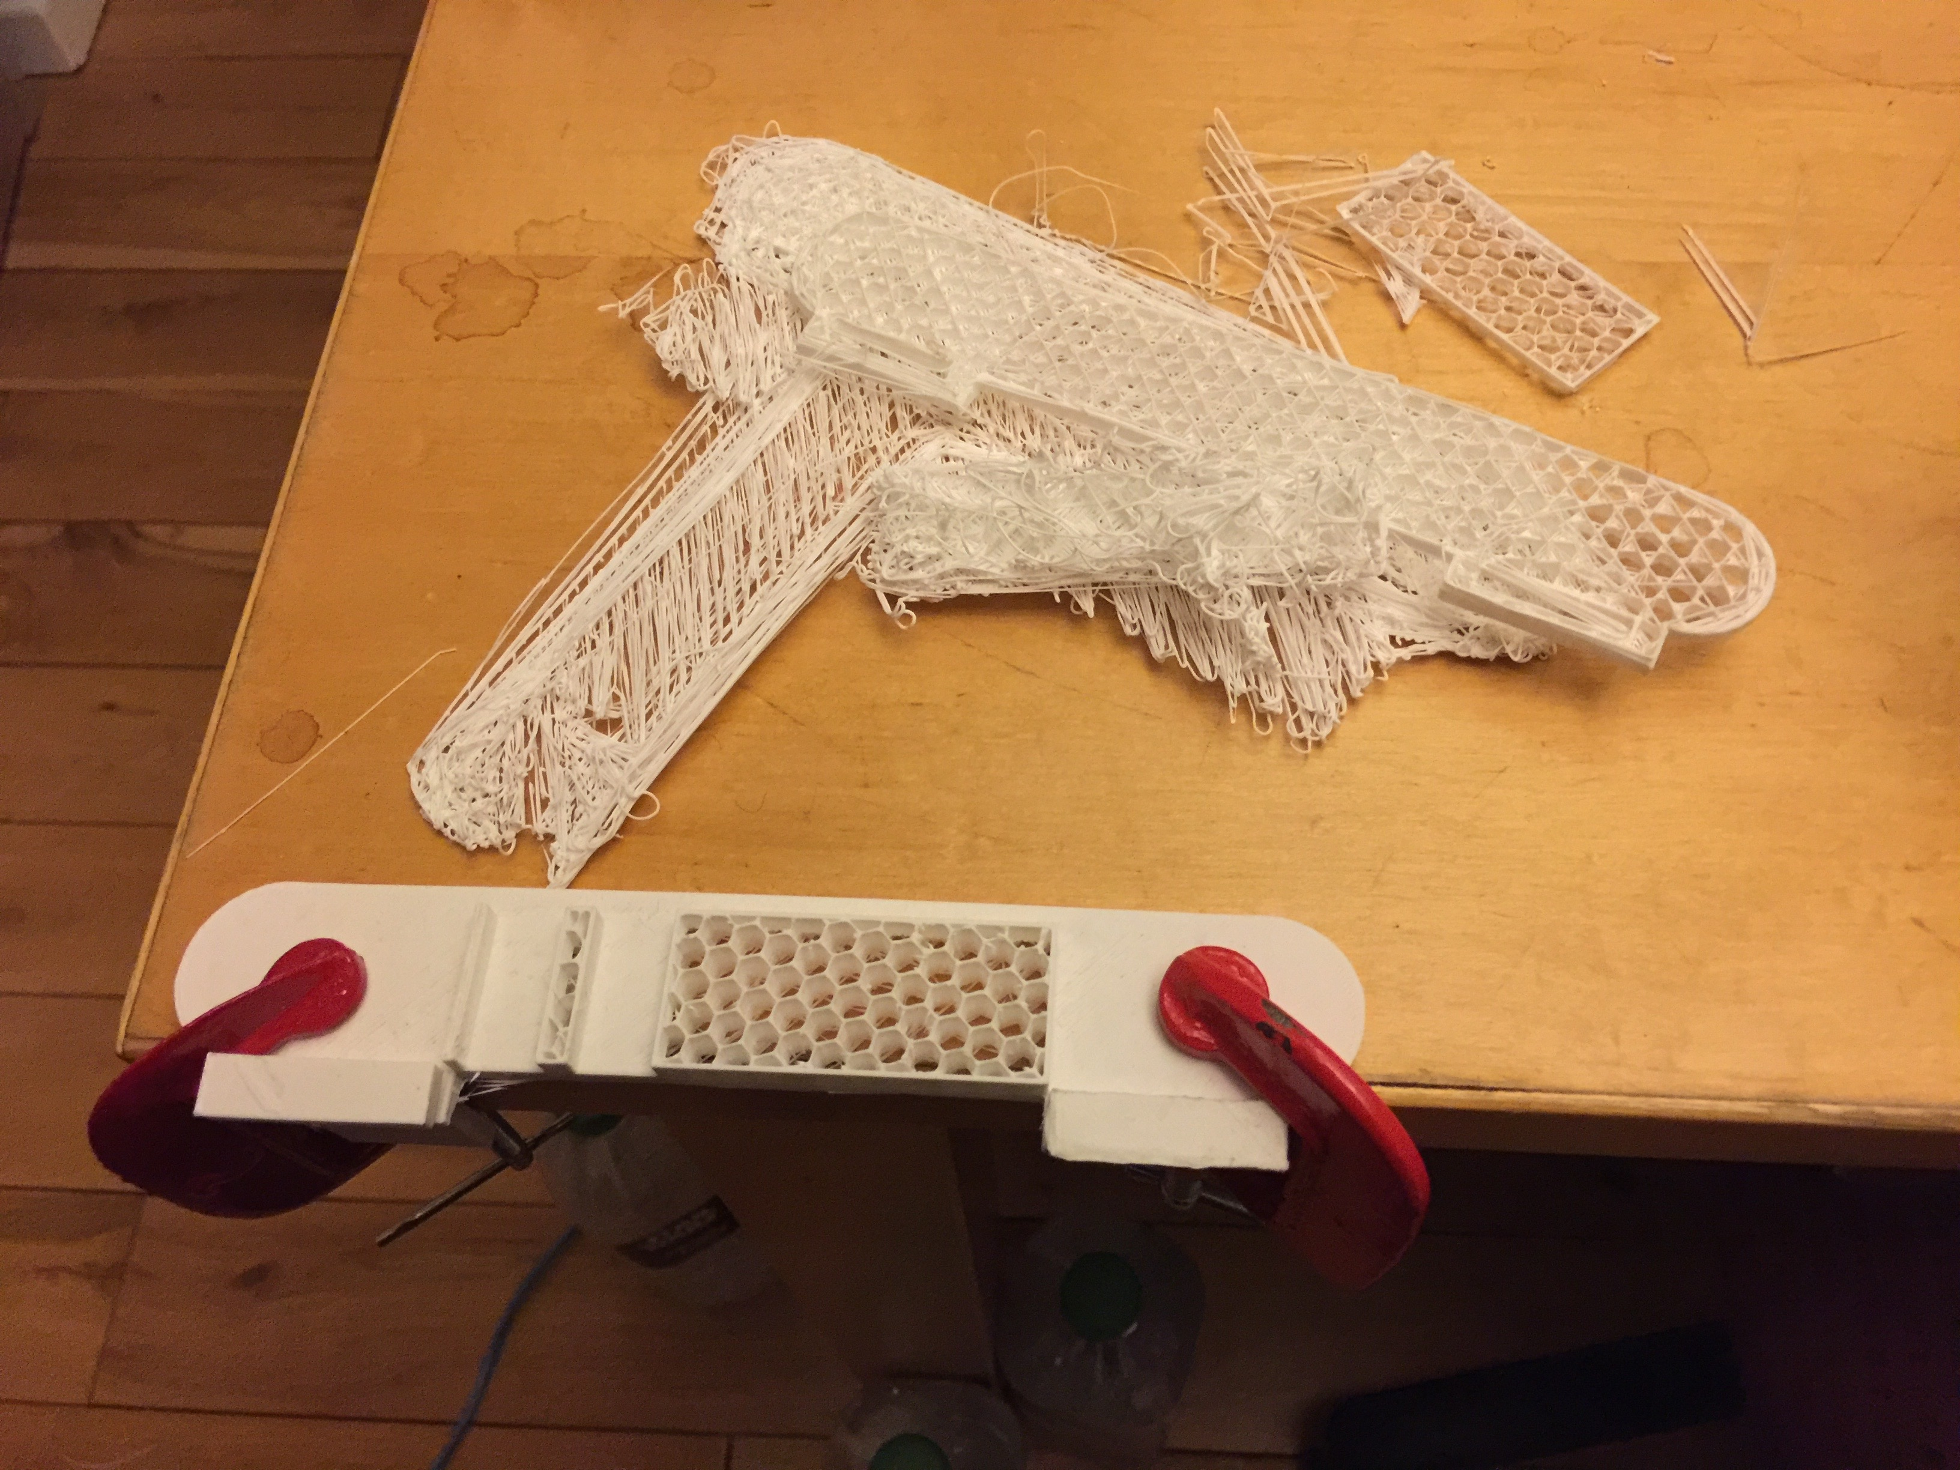

Figure 1: My 3d printed sawing jig so far - see two 12mm bar holders

# Design and Fabrication of Main Wheel Hub

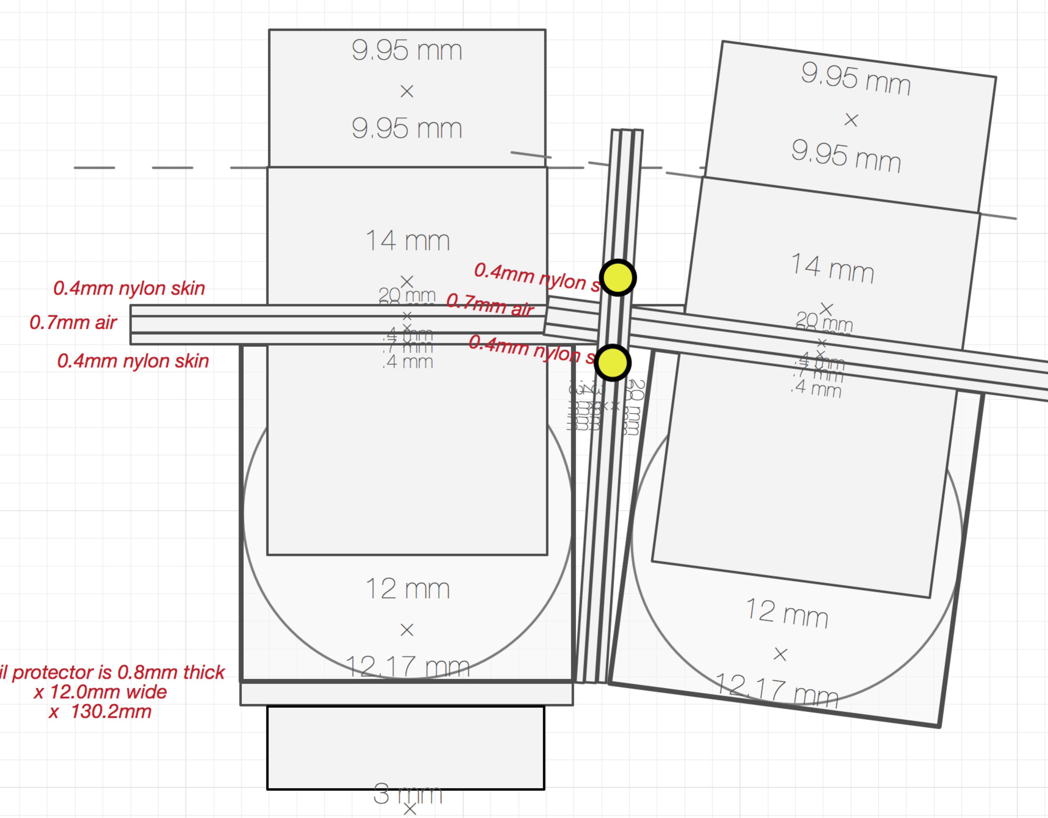

1. I’ve spent much time carefully laying out the exact geometry for the magnetic circuit to the nearest 0.1mm.
   1. I started with the above exactly to scale redraw based on exact measurements of the metal I’ve purchased (and had delivered).
   2. I’ve learned the language of an extension to OpenSCAD called the General Library of Relativity … its brilliant, allows components to be laid out relative to each other, rather than in absolute terms relative to the origin.
   3. A metal part inserted into a plastic hole needs an allowance of 0.3mm (shared into 0.15mm on each side) so that it can slide in – and let the air out. These are all designed in. There are some places where metal touches metal or where parts are held in by covers where the 0.3mm clearance is not needed. All designed in.
2. I’ve designed two covers to hold the magnetic circuit parts firmly into their places.
3. It may be necessary to design springs to hold parts in place taking into account variations due to cutting tolerances. This can be in Mark II.

## The Electromagnetic Circuit – this is now very precise and good!

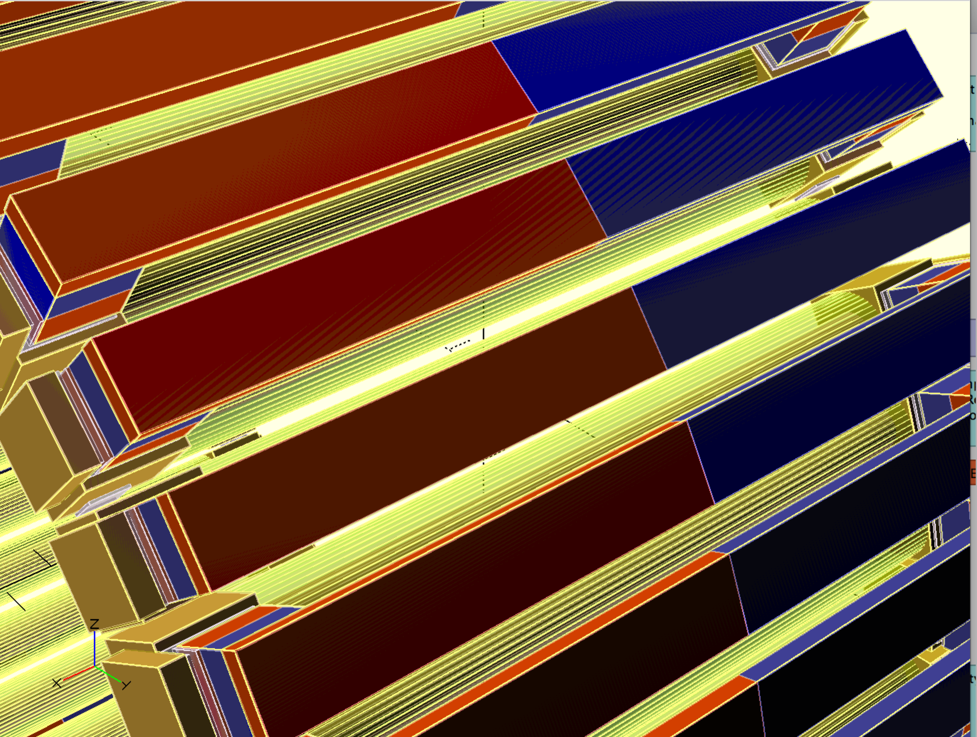

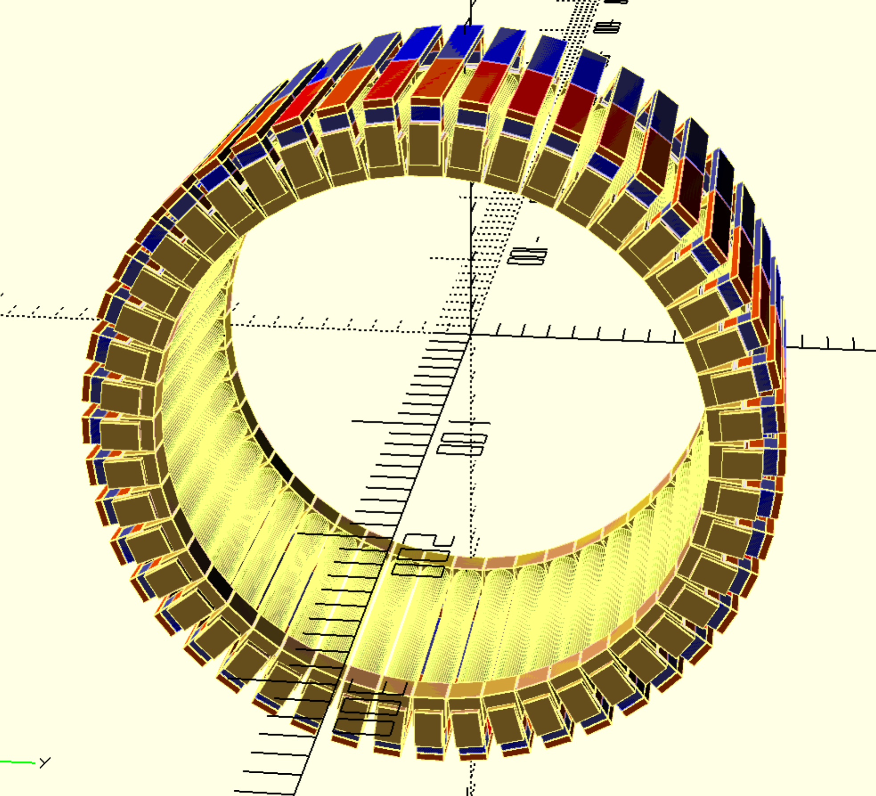

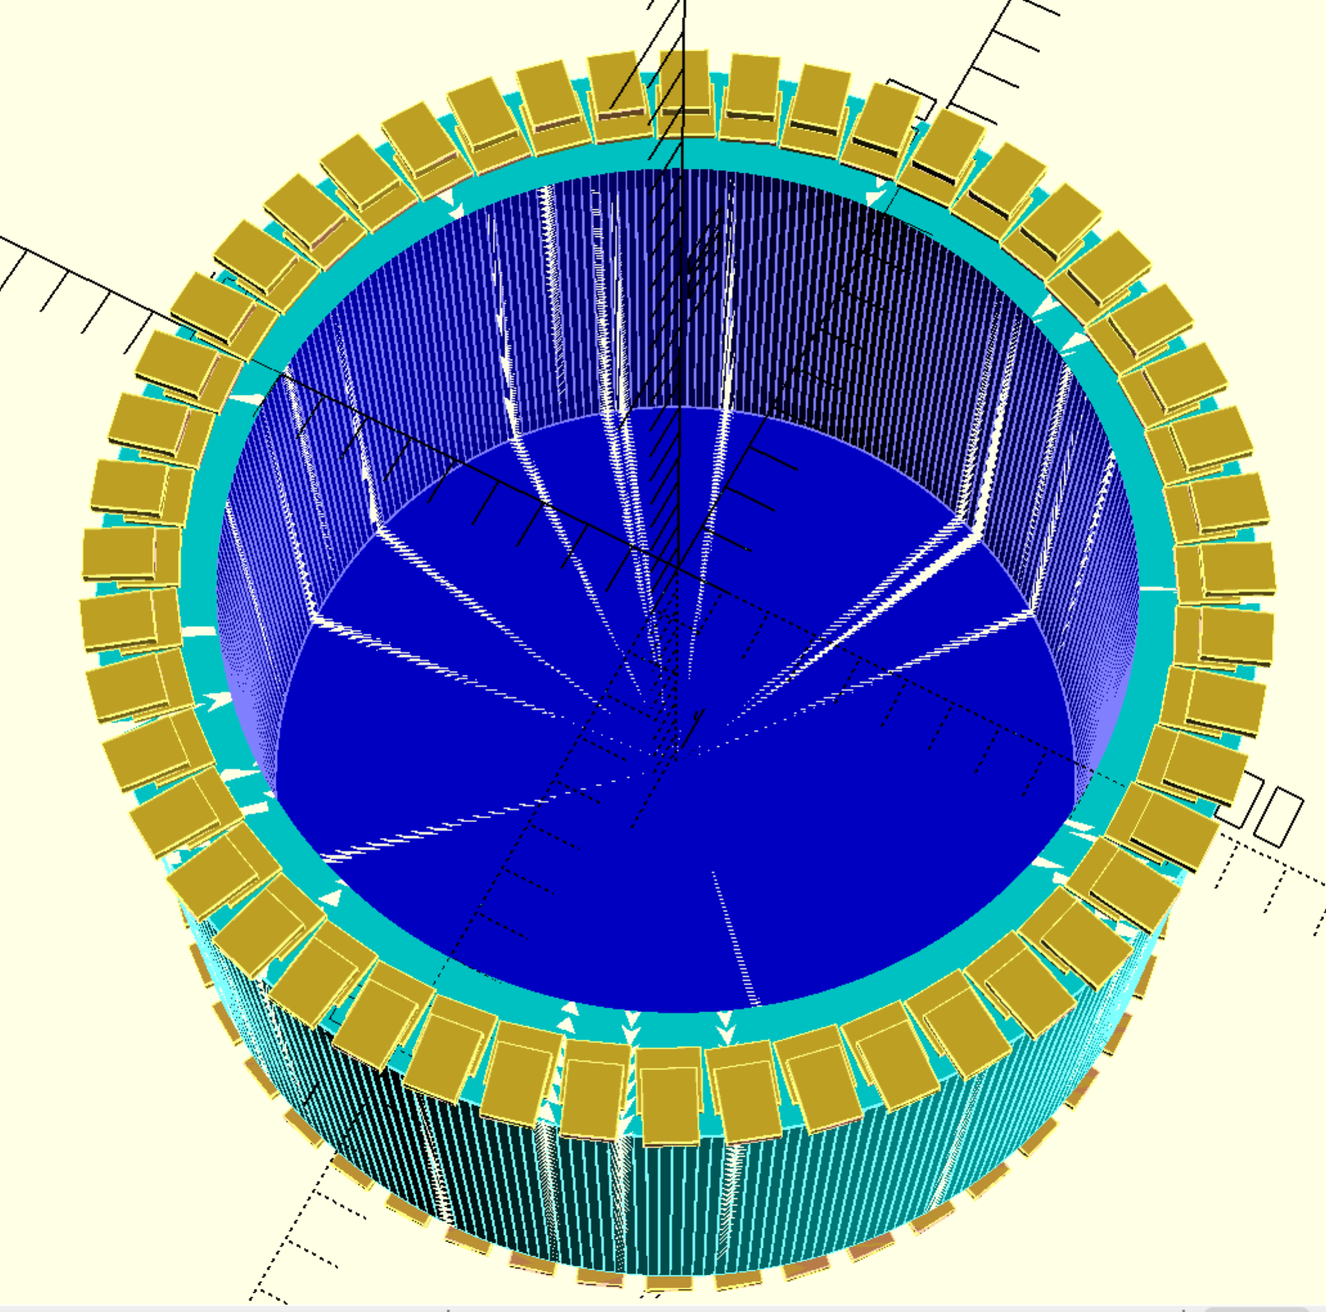

## Covers for Electromagnetic elements lined up for printing

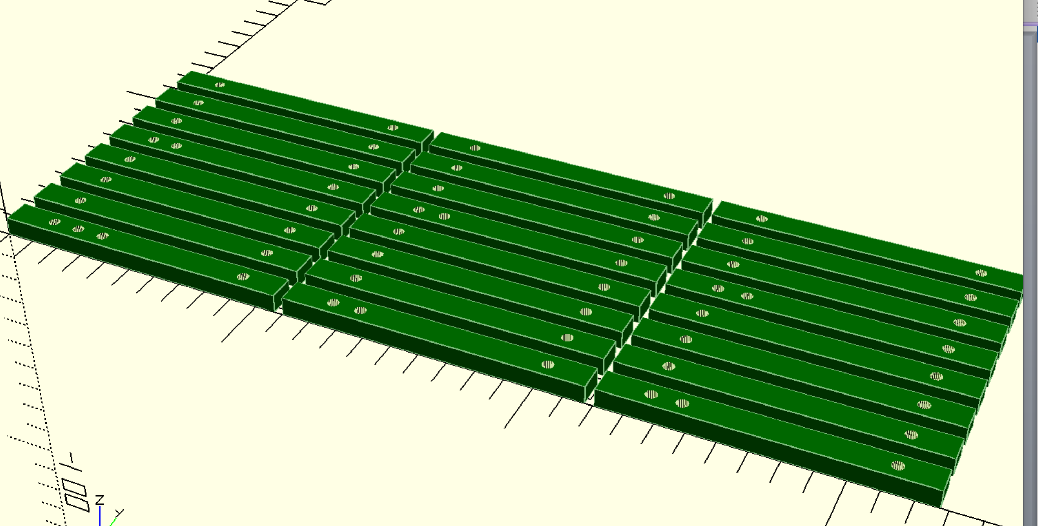

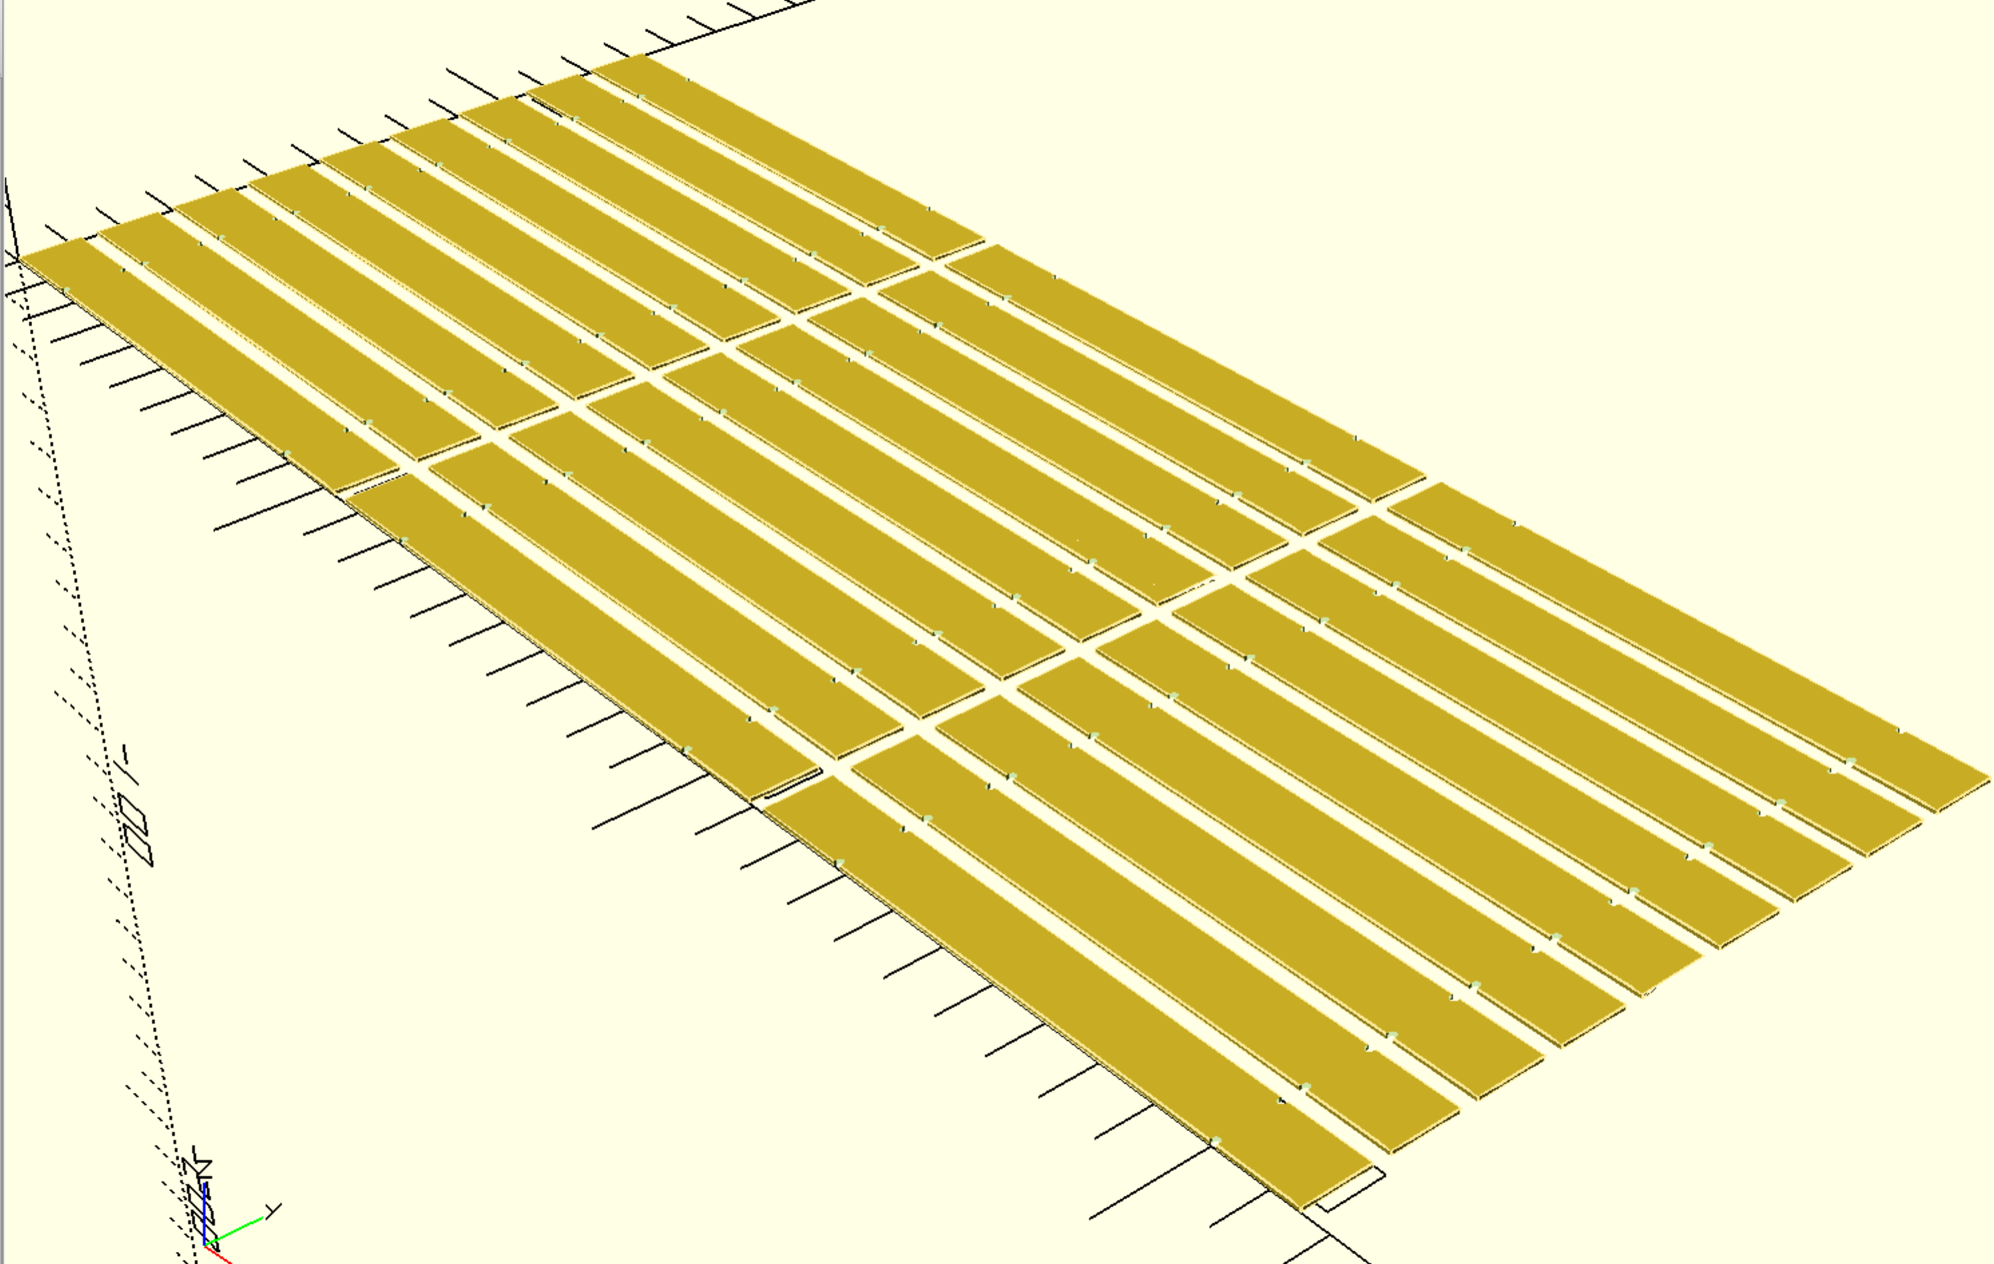

# Printer – Making it more reliable

* **I changed the bolt the spool is resting on to one that is smoother.**
* I did many prints (print attempts) that tended to stop feeding filament after very roughly half an hour. Or the upper layers
* I need to
  + **Where I’ve washed off or scraped of the surface that makes the print bed sticky the filament is not securing properly to the print bed. Clean off and reapply and dry.**
  + Ensure that the knurled wheel that feeds the filament is properly lined up and engaged
  + Get delivered and installed the ball bearing races for the feed
  + **Level the print bed**
    - Get automatic print bed levelling to work – appears to need Z end stop moving from the top to the bottom. Try first with the bottom Z end stop, with setting of add 1mm (as per video) to see if that can be made to work.
  + Order new knurled wheel for feeding filament
* Complete installation of the following
  + Front LCD control panel, allowing prints to be run from SD card
  + Print the chains for tidying the X and Z cables
  + Move the Rambo control board to the left and rear to better support cable tidy up.
  + Tidy up the cables putting them in the printed chains.
  + Put the covers on the printer sides
  + Install the lights that glow behind the logos
  + Install the LCD lights that illuminate work in progress
  + When the first print head is running smoothly get

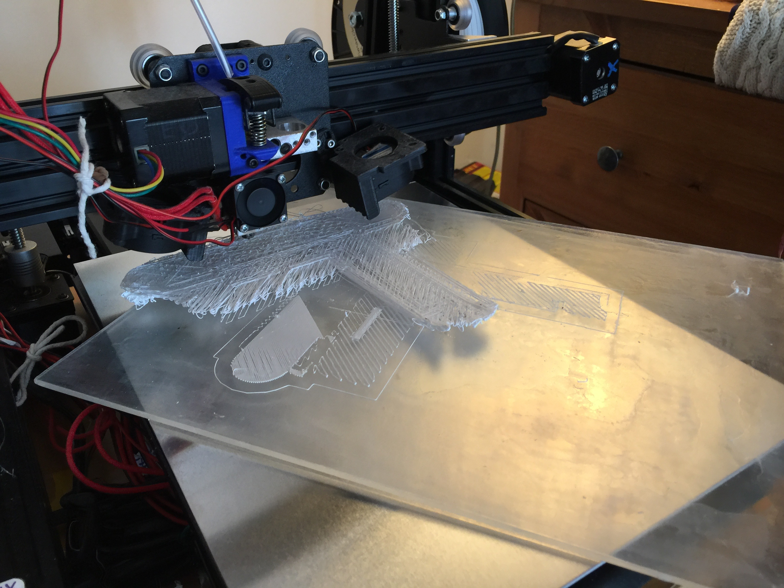

Figure 2: What you can find upon returning to printer!

# Three main next steps

1. Chop up the metal: 48 circuits with 6 cuts 9 parts each (including magnets and copper). Preferred route: angle grinder on saw table
2. Improve the 3D printing with better filament spool bearings, better bed glue and better bed levelling.
3. Main job: Continue/Complete 3D modelling of parts to cut and print, assuring all fits together neatly.
   1. Stator: i) refine long thin bar position with parameterised calculations to account for rod being exactly 100mm long, ii) parameterised calculation for biscuit tin dimensions, iii) create rim that avoids ball bearings {covering exposed parts in pictures above} iv) the copper electromagnetic coil covers [inner and outer] make the spaces for them and ensure fit well v) mounts for M3 inserts 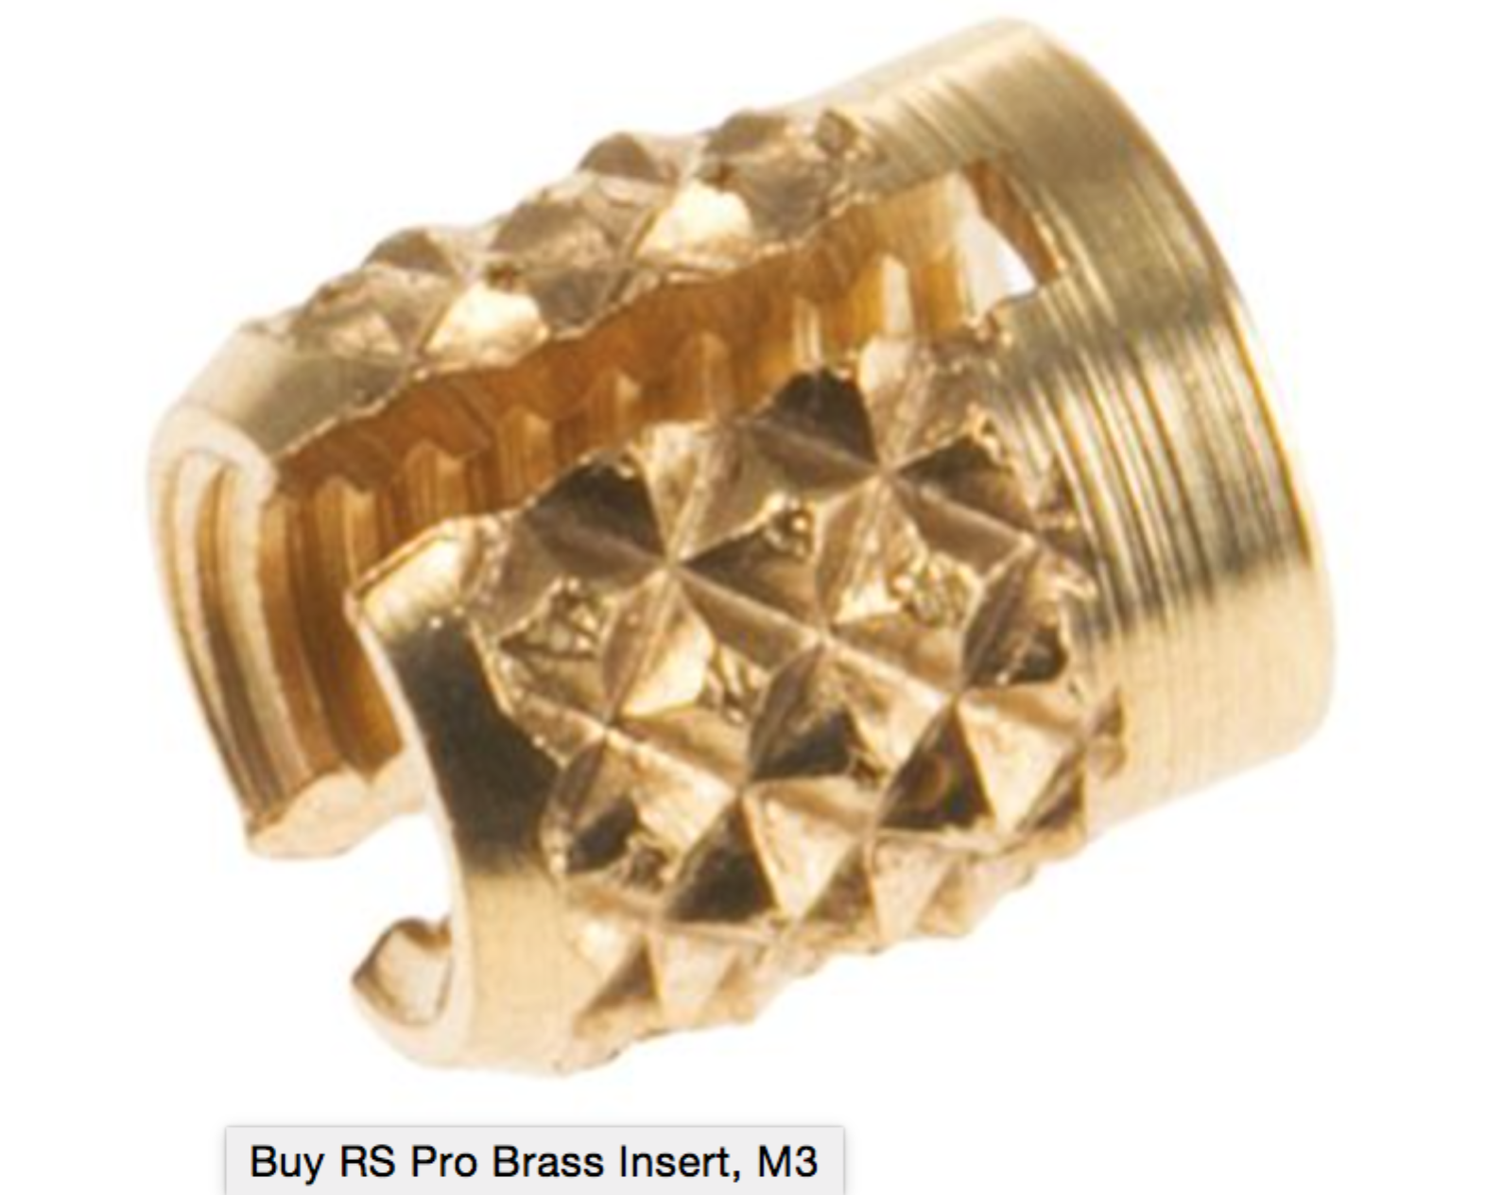 I’ve bought for mounting electronics in plastic biscuit tin. Vi) basic rotor, vii) make routes for copper wires to pass through rotor and stator to support touch detection. Viii) ‘tower of light’ assembly for optical detection of position ix) three bolt holes for attaching the biscuit tin to the bike x) hole and fitting for cables for power and information {it’s a USB cable}. Xi) Lid, XII) spokes. Xiii) and then move on to circuitry and software!